CHE507 ADVANCED PROCESS CONTROL
FINAL EXAM

Professor Shi-Shang Jang 6/26/07

Problem #1 (25%)
Air and water streams are fed into a pressurized tank through two control valves. Air flows out of the top of the tank through a restriction, and water flows out the bottom through another restriction. The linearizied equations describing the system are
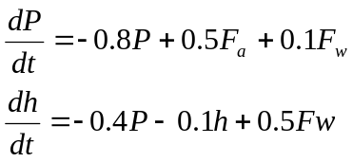
where P= pressure
h= liquid height
F_{a}= air flow rate into tank
F_{w}= water flow rate into tank
Use state variable methods to calculate:
- The open loop eigenvalues and the open loop transfer function matrix.
- Calculate the RGA, what is the suitable pairing for two SISO controller?
- Design a decoupling algorithm for this system.

Problem #2 (25%)

Consider the following Internal Model Control Structure (or Model Predictive Control Structure:
G_{I}
G_{m}
G_{P}
y_{s}
e
d
y
y_{m}
u
+
+
+
-
-
+

Show that:

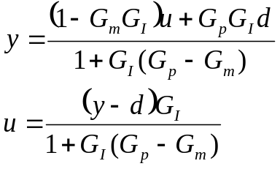

Based on the above derivation, also show that:
- Dual stability: y and u are both stable provided that G_{p}=G_{m}, G_{p} and G_{I} are stable.
- Perfect Control: y=y_{s} provided that G_{p}=G_{m}, G_{p}=G_{I}⁻¹ and G_{I} realizable.
- Zero offset: y(0)=y_{s}(0) provided that G_{m}(0)=G_{I}⁻¹(0).

Problem #3 (25%) Consider the following plant transfer functions:
(1)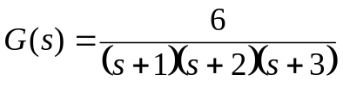
(2) 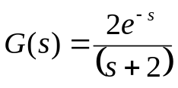

- Find frequency responses for the above plants.
- Make Bode and Nyquist plots using the results of (i).
- Find the ultimate gains and ultimate frequencies of the above plants.

Problem #4 (25%)
A cascade control configuration is sometimes used to separate different objectives of feedback control. For instance, first an inner loop can be used to stabilize the process, and then an outer loop can be used to control the output to track set-point changes and reject disturbances. An example of a cascade control system is shown in the following figure. The process transfer function
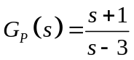
is unstable.
- Determine the maximum range of Kc₂ values for which the inner loop will be stable.
- Now assume Kc₂=6 and Gc₁ is a PI controller with gain Kc₁ and τ_{I}. Find the values of Kc₁ and τ_{I} such that the closed-loop poles of the transfer function from Y_{sp} to Y(s) are at s=-0.5±0.2j.

